

oneM2M
Technical Report
Document Number | oneM2M-TR-0047-V-0.0.2
Document Name: | Developer Guide of 3GPP Interworking
Date: | <2018-Jan-25>
Abstract: | Provides a use case for guiding application developers to develop applications using 3GPP interworking functionalities provided by a oneM2M service platform.
Template Version: January 2017 (Do not modify)

The present document is provided for future development work within oneM2M only. The Partners accept no liability for any use of this report.
The present document has not been subject to any approval process by the oneM2M Partners Type 1. Published oneM2M specifications and reports for implementation should be obtained via the oneM2M Partners' Publications Offices.

About oneM2M
The purpose and goal of oneM2M is to develop technical specifications which address the need for a common M2M Service Layer that can be readily embedded within various hardware and software, and relied upon to connect the myriad of devices in the field with M2M application servers worldwide.
More information about oneM2M may be found at: http//www.oneM2M.org
Copyright Notification
© 2017, oneM2M Partners Type 1 (ARIB, ATIS, CCSA, ETSI, TIA, TSDSI, TTA, TTC).
All rights reserved.
The copyright and the foregoing restriction extend to reproduction in all media.

Notice of Disclaimer & Limitation of Liability
The information provided in this document is directed solely to professionals who have the appropriate degree of experience to understand and interpret its contents in accordance with generally accepted engineering or other professional standards and applicable regulations. No recommendation as to products or vendors is made or should be implied.
NO REPRESENTATION OR WARRANTY IS MADE THAT THE INFORMATION IS TECHNICALLY ACCURATE OR SUFFICIENT OR CONFORMS TO ANY STATUTE, GOVERNMENTAL RULE OR REGULATION, AND FURTHER, NO REPRESENTATION OR WARRANTY IS MADE OF MERCHANTABILITY OR FITNESS FOR ANY PARTICULAR PURPOSE OR AGAINST INFRINGEMENT OF INTELLECTUAL PROPERTY RIGHTS. NO oneM2M PARTNER TYPE 1 SHALL BE LIABLE, BEYOND THE AMOUNT OF ANY SUM RECEIVED IN PAYMENT BY THAT PARTNER FOR THIS DOCUMENT, WITH RESPECT TO ANY CLAIM, AND IN NO EVENT SHALL oneM2M BE LIABLE FOR LOST PROFITS OR OTHER INCIDENTAL OR CONSEQUENTIAL DAMAGES. oneM2M EXPRESSLY ADVISES ANY AND ALL USE OF OR RELIANCE UPON THIS INFORMATION PROVIDED IN THIS DOCUMENT IS AT THE RISK OF THE USER.

Contents
Contents 3
1 Scope 4
2 References 4
2.1 Normative references 4
2.2 Informative references 4
3 Definitions, symbols and abbreviations 4
3.1 Definitions 4
3.2 Symbols 5
3.3 Abbreviations 5
4 Conventions 5
5 Use case 6
6 Architecture 6
7 Procedures 6
7.1 UE Attach with oneM2M Registration Procedure 6
8 Implementation 6
8.1 Introduction 6
8.2 Assumptions 6
8.3 Resource Structure 6
8.7 Implementation Procedures 6
Proforma copyright release text block 6
Annexes 6
History 7

1 Scope
The present document …
EXAMPLE: The present document provides the necessary adaptions to the endorsed document.
The Scope shall not contain requirements.

2 References
The following text block applies.
References are either specific (identified by date of publication and/or edition number or version number) or non-specific. For specific references,only the cited version applies. For non-specific references, the latest version of the referenced document (including any amendments) applies.

2.1 Normative references
As a Technical Report (TR) is entirely informative it shall not list normative references.
The following referenced documents are necessary for the application of the present document.
Not applicable.

2.2 Informative references
Clause 2.2 shall only contain informative references which are cited in the document itself.
The following referenced documents are not necessary for the application of the present document but they assist the user with regard to a particular subject area.
[i.1] oneM2M Drafting Rules (http://member.onem2m.org/Static_pages/Others/Rules_Pages/oneM2M-Drafting-Rules-V1_0.doc)

3 Definitions, symbols and abbreviations
Delete from the above heading the word(s) which is/are not applicable.

3.1 Definitions
Clause numbering depends on applicability.
- A definition shall not take the form of, or contain, a requirement.
- The form of a definition shall be such that it can replace the term in context. Additional information shall be given only in the form of examples or notes (see below).
- The terms and definitions shall be presented in alphabetical order.
For the purposes of the present document, the [following] terms and definitions [given in ... and the following] apply:
Definition format
<defined term>: <definition>
If a definition is taken from an external source, use the format below where [N] identifies the external document which must be listed in Section 2 References.
<defined term>[N]: <definition>
example 1: text used to clarify abstract rules by applying them literally
NOTE: This may contain additional information.

3.2 Symbols
Clause numbering depends on applicability.
For the purposes of the present document, the [following] symbols [given in ... and the following] apply:
Symbol format
<symbol> <Explanation>
<2nd symbol> <2nd Explanation>
<3rd symbol> <3rd Explanation>

3.3 Abbreviations
Abbreviations should be ordered alphabetically.
Clause numbering depends on applicability.
For the purposes of the present document, the [following] abbreviations [given in ... and the following] apply:
Abbreviation format
<ABBREVIATION1> <Explanation>
<ABBREVIATION2> <Explanation>
<ABBREVIATION3> <Explanation>

4 Conventions
The key words “Shall”, ”Shall not”, “May”, ”Need not”, “Should”, ”Should not” in this document are to be interpreted as described in the oneM2M Drafting Rules [i.1]

5 Use case

5.1 UE Reachability monitoring
A water meter application wants to send firmware upgrade message to the water meter with SIM card. Before the application send the upgrade message, it should check the reachability status of the target device which may be in power saving mode to make sure the device can receive the upgrade message. In this case, the child resource <schedule> of the resource <node> is used to indicate the time of reachability status of the target device. The application can get to know the available status by subscribing to the <schedule> resource.
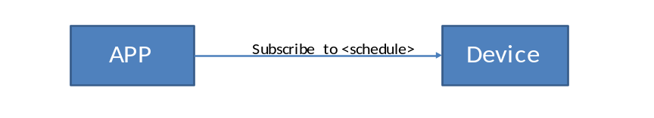
Figure: 5.1-1: Use case for UE Reachability monitoring

6 Architecture

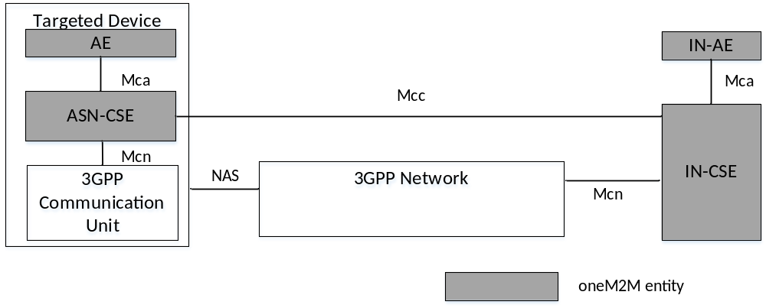
Figure: 6-1: Architecture for 3GPP interworking
The Applications that are hosted on the devices correspond to oneM2M ASN. The Applications hosted in the cloud corresponds to oneM2M IN-AEs which connect to a service layer platform, i.e. oneM2M IN-CSE, to communicate with the targeted devices. The application hosted on the device could be ADN-AE, ASN or MN,or the device may host as a noDN. It depends on the implementation. To provide all features for the application, the devices can be ASN which have the capability to host oneM2M resources.

7 Procedures
<Text> Describe the 3GPP interworking service flow of the specified use case.

7.1 UE Attach with oneM2M Registration Procedure

8 Implementation
<Text> Describe the detail implementation procedure of the specified use case.

8.1 Introduction

8.2 Assumptions

8.3 Resource Structure

8.5 Implementation Procedures

Proforma copyright release text block
This text box shall immediately follow after the heading of an element (i.e. clause or annex) containing a proforma or template which is intended to be copied by the user. Such an element shall always start on a new page.
Notwithstanding the provisions of the copyright clause related to the text of the present document, oneM2M grants that users of the present document may freely reproduce the <proformatype> proforma in this {clause|annex} so that it can be used for its intended purposes and may further publish the completed <proformatype>.
<PAGE BREAK>

Annexes
Each annex shall start on a new page (insert a page break between annexes A and B, annexes B and C, etc.).
Use the Heading 9 style for the title and the Normal style for the text.
Annex <A>:
Title of annex (style H9)
<Text>
<PAGE BREAK>

History
This clause shall be the last one in the document and list the main phases (all additional information will be removed at the publication stage).
Publication history
V1.1.1 | <yyyy-mm-dd> | <Milestone>

Draft history (to be removed on publication)
V0.0.1 | 2017-09-11 | Includes agreed contribution at TP#31 meeting:  TST-2017-0227
V0.0.2 | 2018-01-25 | Includes agreed contribution at TP#33 meeting:  TST-2018-0001R02

